Research Newsletter
School of Computer Science

Issue 5 – Summer/ Autumn 2015

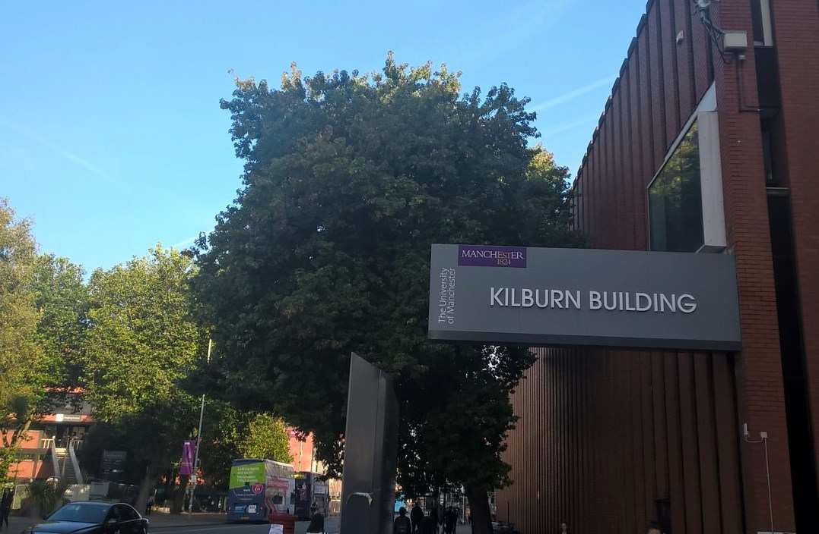

In this issue

p.2 Head of School Editorial and Research News
  - Feature – Partnering with the BBC
  - Spotlight – Citation Successes
  - Recent Promotions
p.6 Grants and Awards
p.8 Industry Study Groups

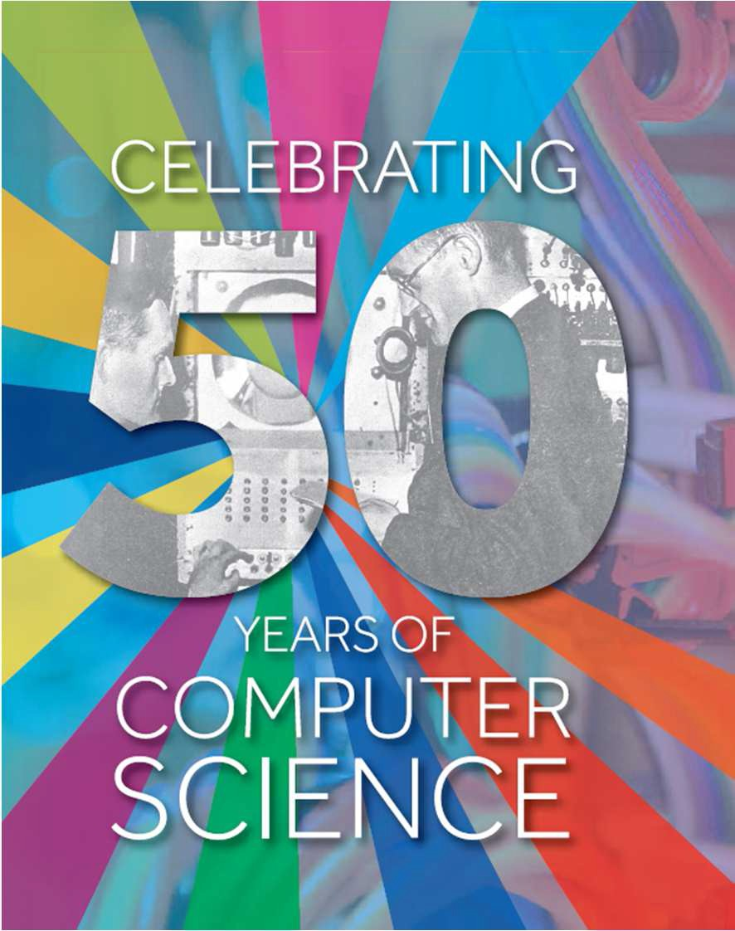About us
The School of Computer Science - Kilburn Building

Contact us

School of Computer Science The University of Manchester Kilburn Building
Manchester M13 9PL UK

Email: researchsupportcsm@manchester.ac.uk Web: www.cs.manchester.ac.uk

At The University of Manchester, we have one of the longest established schools of computer science in the UK and one of the largest. We are constantly building on our strong research history with research groups operating across the spectrum of computer science, from fundamental theory and innovative technology, through novel hardware and software systems design, to leading-edge applications.
The School is consistently ranked highly; top 5% in the UK (REF2014, GPA); assessed as the best environment in the UK for computer science and informatics research (REF2014); 7th in the UK by ARWU 2014 and the expertise and achievements of our staff are well-recognised internationally.

Editorial by the Head of School
In this edition of the School Research Newsletter, there are some great examples of how research in the School is having impact across the sector and more widely with industry.

News

Professor Jim Miles

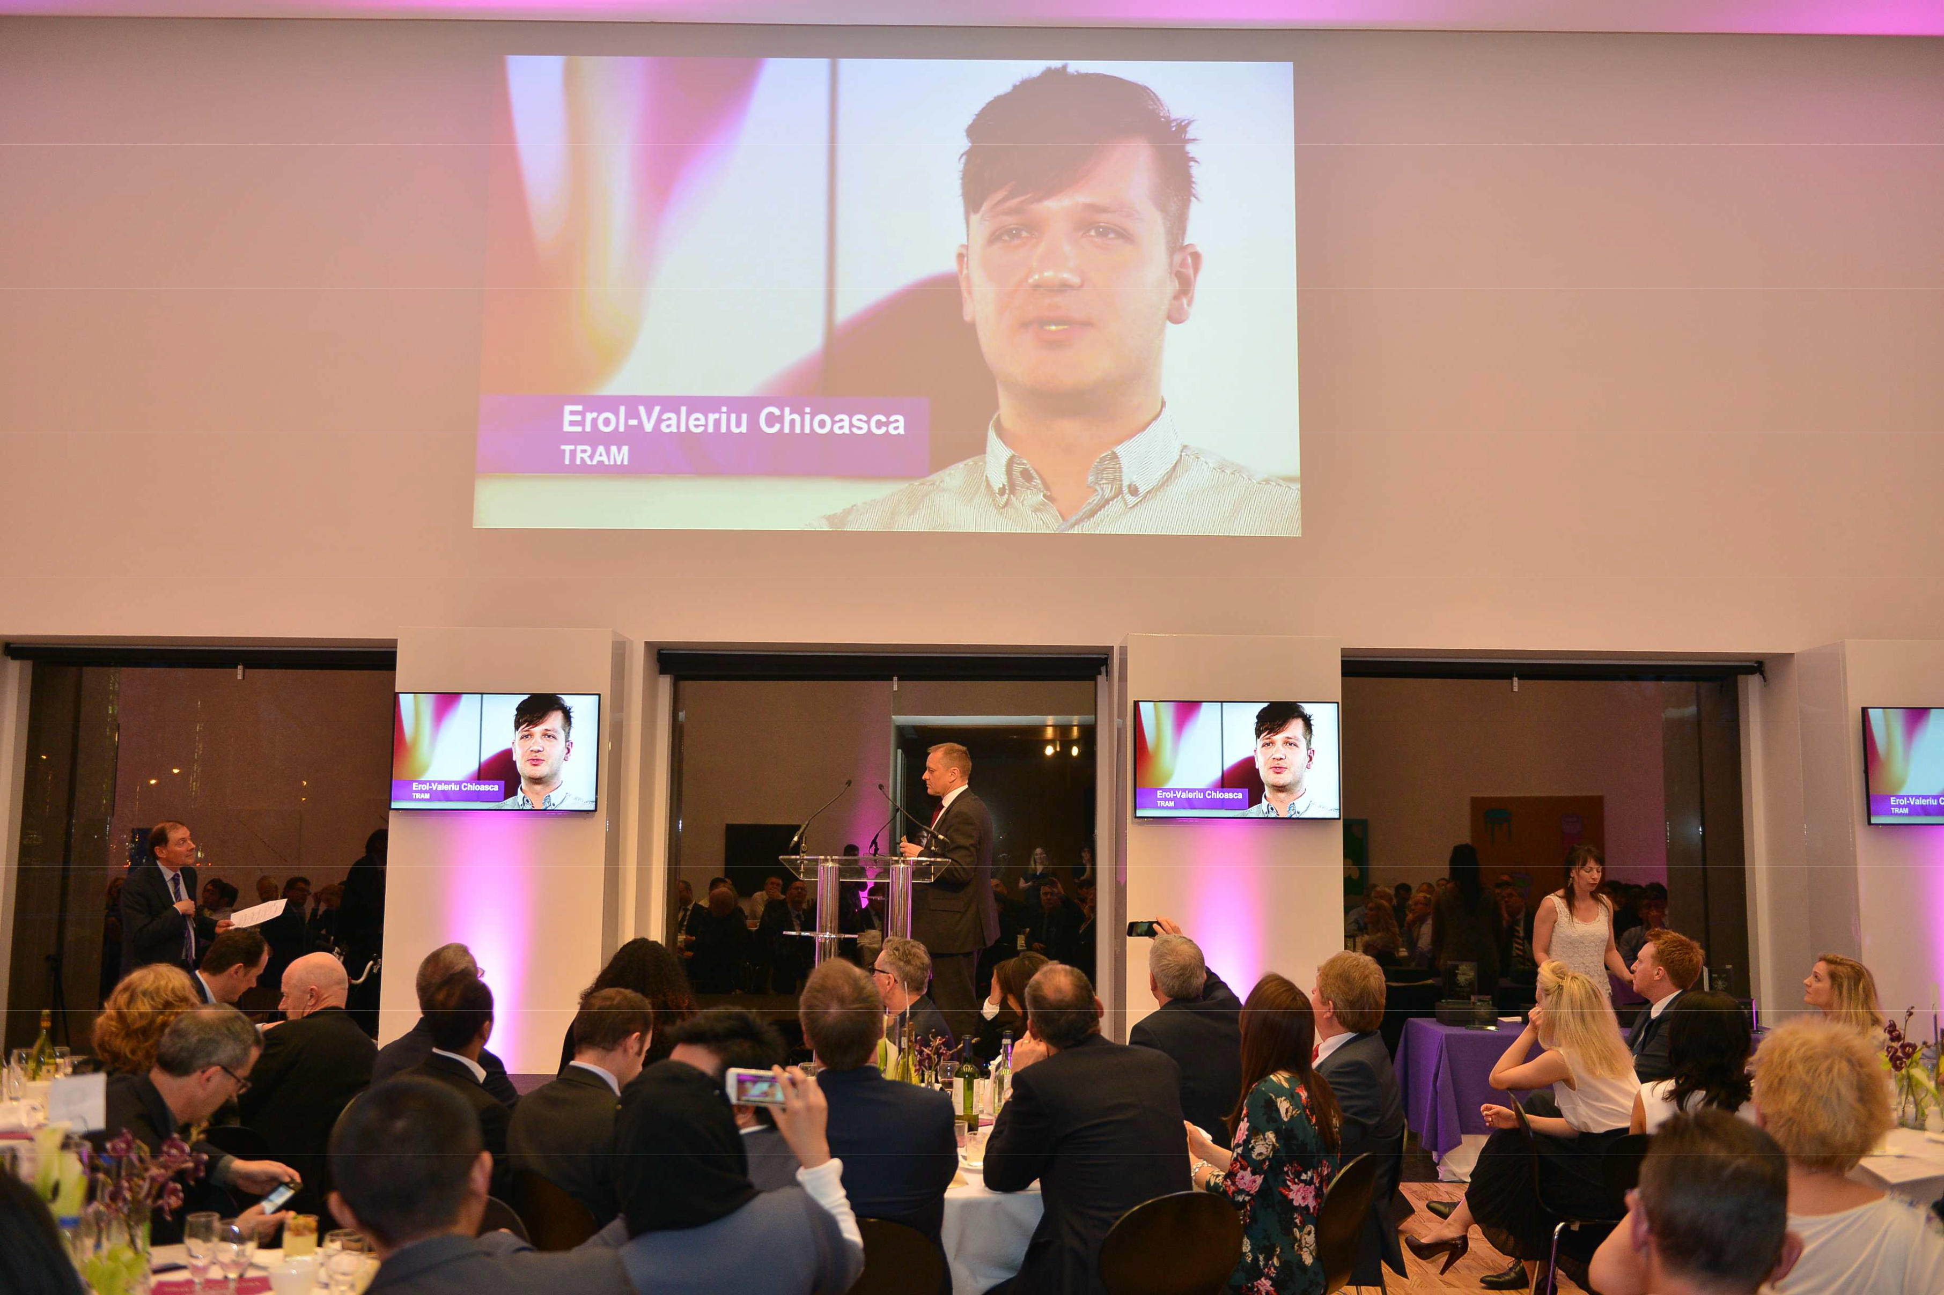£10,000 boost for TRAM business as 2015 Venture Further winners
Congratulations to recent Computer Science PhD graduates Dr Erol Chioasca (supervised by Dr Liping Zhao; co-supervised by Prof. John Keane and Dr Goran Nenadic) and Dr Keletso Joel Letsholo (supervised by Dr Liping Zhao) for winning the Research Category award at the 2015 Venture Further competition.

Software literature shows that the majority of user requirements for software development are written in natural language. Developing initial software models from requirements written in natural language is a skilled job, requiring a significant development effort of several weeks or months. TRAM (Textual Analysis into Analysis Models) is a software tool that supports requirements modelling and analysis in early stages of software development. TRAM offers the following functionality:

- Automatical construction of initial software models from English descriptions of requirements in seconds or minutes;
- Automatical delection of missing, ambigous and inconsistent requirements;
- Interaction with requirements analysts to refine both requirements documents and their corresponding models;
- Model editing facility to allow requirements analysts to directly edit models;
- Requirements management through requirements tracebility links;
- Paraphrasing of models.

Market assessment shows that TRAM has great potential and is currently incubated by UMIP, as the basis of a spinout company. TRAM’s development was led by Dr Liping Zhao, School of Computer Science. For more information on the event see: https://mec.portals.mbs.ac.uk/Newsevents/Enterprisenews/tabid/112/ArticleID/182/ArtMID/510/Four-businesses-given-
%C2%A310000-boost-as-2015-Venture-Further-winners.aspx

NaCTeM’s Jock McNaught in the New

On 9th June 2015, Jock, deputy director of the National Centre for Text Mining (NaCTeM) at Manchester, was quoted in the Guardian higher education network feature on copyright law and text mining, called 'Call to unlock a treasure chest of hidden research data'.
At the moment copyright law limits the amount of data that can be mined by researchers. However, things could be about

to be updated with the possibility that the European Commission may update its 2001 copyright laws to better suit the digital age. This could give researchers greater access to published work - with access to non-open access articles. For the full article see: http://www.theguardian.com/higher-education- network/2015/jun/09/call-to-unlock-a-treasure-chest-of-
hidden-research-data

Dr Daniel Dresner on the BBC
Dr Daniel Dresner was interviewed on several BBC radio and television news outlets about attitudes to cyber crime, security breaches, ongoing threats to payment card security, and the notorious Ashley Madison
hack http://www.bbc.co.uk/news/world-33608636. Issues varied from the challenge of getting a non- technical understanding of technology and the morals and ethics of untrustworthy software. Dr Dresner
appeared on the One o’clock news, BBC Two, BBC World News, BBC Radio Five Live, BBC Radio Scotland, and BBC Coventry and Warwickshire Radio, BBC Radio Two. www.cs.manchester.ac.uk/about-us/staff/profile/?ea=daniel.dresner (image courtesy of www.perspecsys.com)

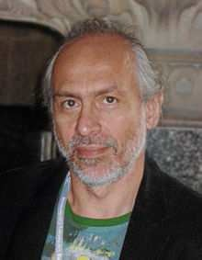Prof. Voronkov to receive Herbrand Award for Distinguished Contributions to Automated Reasoning
Andrei Voronkov is this year's winner of the Herbrand Award. The award was presented to him at the 25th International Conference on Automated Deduction held in Berlin in August 2015.

The award is in recognition of his numerous theoretical and practical contributions to automated deduction, and the development of the award-winning Vampire theorem prover. Congratulations to Andrei! www.cadeinc.org/HerbrandAward.html

BBSRC Business magazine features Robot Scientist ‘Eve’
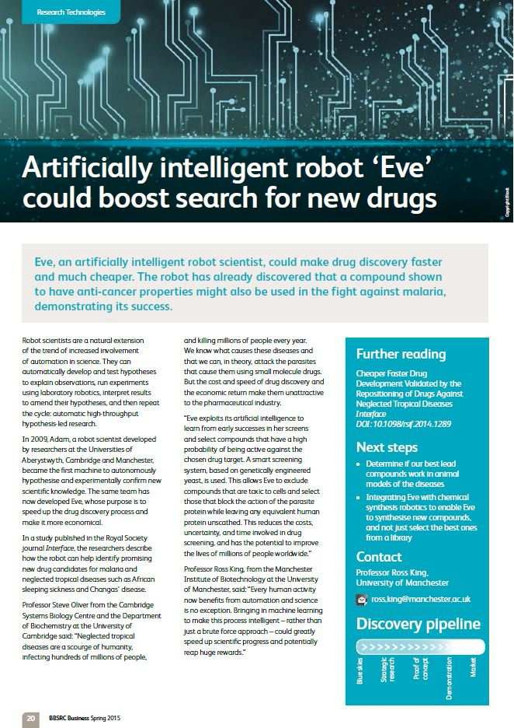The BBSRC-funded research involving Robot Scientist ‘Eve’ appears in the Spring edition of BBSRC Business.
In a recent paper the researchers from Manchester and Cambridge describe how the robot can help identify promising new drug candidates for malaria and neglected tropical diseases such as African sleeping sickness and Changas' disease.

“Every human activity now benefits from automation and science is no exception. Bringing in machine learning to make this process intelligent – rather than just a brute force approach – could greatly speed up scientific progress and potentially reap huge rewards.” According to Professor Ross King.

The use of Robot Scientists reduces the costs, uncertainty, and time involved in drug screening, and has the potential to improve the lives of millions of people worldwide.

To read the full article go to: www.bbsrc.ac.uk/news/business-magazine/2015/spring-2015/ (p.20)

Prof. King’s Robot Scientist research group took part in an exhibition on artificial intelligence at the Science Museum in London (late August 2015). https://twitter.com/sciencemuseum/status/636466871164768256

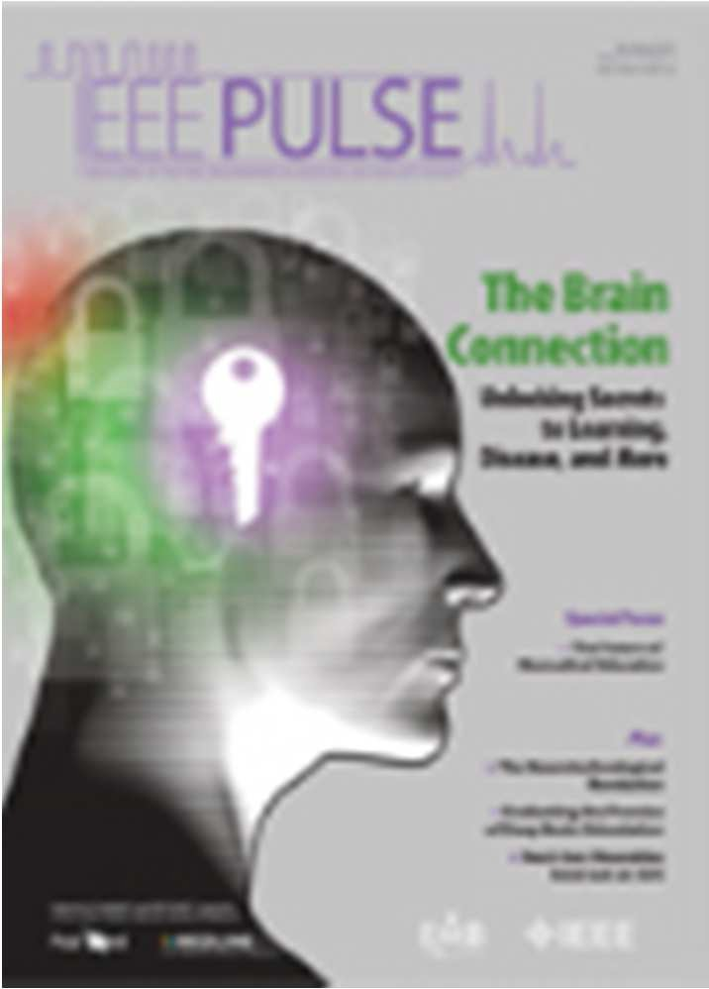IEEE Pulse magazine feature article with Professor Steve Furber
The SpiNNaker project and its involvement in the EU Flagship Human Brain Project features in the piece.

“My work focuses both on using the computer power now available to improve our understanding of the brain and on using the brain to build better computers.

“I hope that we can remove the computational limitations on what most computational neuroscience groups have done." Prof. Furber.

To read the full article see: http://pulse.embs.org/march-2015/neurotechnological-revolution/

Check out the latest podcast from Computer Science, featuring Prof.
Furber: http://epscommunity.tumblr.com/post/129629764180/professor-steve-furber-and-the-human-brain-project

Front cover feature for research on magnetisation reversal

Post-doctoral researcher Craig Barton and Professor Tom Thomson's work ‘Magnetisation reversal in anisotropy graded Co/Pd multilayers’ has recently been published in the Journal of Applied Physics as a featured article which made the front cover. The image shows the magnetisation reversal data for multiple thin layers of directional colbalt/ palladium. The reversibility of these systems
is important for the development of future nanoscale technologies such as bit patterned media (BPM) recording and spin-torque transfer (STT) devices.
The full paper is available through: http://dx.doi.org/10.1063/1.4927726

Partnering with the BBC to take forward research

Drs Simon Harper and Caroline Jay have been working closely with the BBC with funding through the EPSRC Impact Acceleration Account (IAA).

In 2013, at the start of the IAA scheme, Dr Harper was awarded a 6-month Relationship Incubator grant to work with the BBC on the use of multiple-devices whilst watching TV. The project was key in demonstrating that the experimental set-up and analysis techniques were feasible with synched devices.

‘The bilateral visits and meetings with the BBC have been mutually beneficial; the Interaction Analysis and Modelling (IAM) team from Manchester provided up-to-date eye-tracking facilities and expertise, alongside willing student test participants, and the BBC were able to provide access to their testing suite (set in a living room environment) and a different demographic of participants.’
Dr Harper

A subsequent year-long IAA Industrial Secondment with the BBC focussed on obtaining more results and extending the technology to understand when viewers switch attention from the TV to another device. These results will help researchers to understand when attention is maintained and how best to segment programmes when a second device such as a tablet or mobile is being used with additional programme-related content.

The facilities and expertise at Manchester and the BBC have been complimentary to each other; the relationship has successfully helped to transfer methodology into the BBC for use with high-level eye tracking and proved the value of more technical computer scientists in this area of research.
www.manchester.ac.uk/research/simon.harper/

Academics in the School of Computer Science have been transferring their expertise to companies with a variety of IAA schemes as shown below:

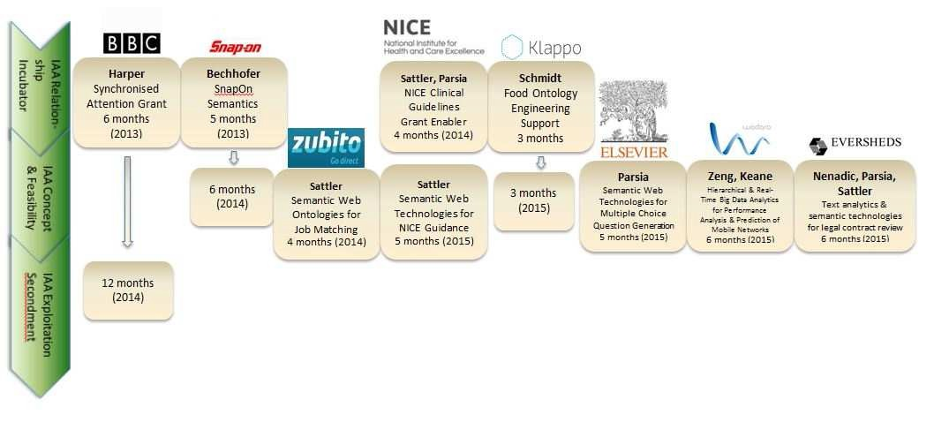

IAA funding at the University aims to maximise the economic and social impact of EPSRC-funded research by facilitating work with
external partners. It funds a range of support mechanisms, from initial engagement and collaboration, through to commercialisation.
For more information on Impact Acceleration Accounts and how you and your company could get involved see:
www.manchester.ac.uk/collaborate/business-engagement/knowledge-exchange/collaboration-funding/
4

Spotlight: Citation successes

Publications from the School are making a stir across Computer Science
Google Scholar recently released the "Scholar Metrics 2015", which summarizes all papers they index. https://scholar.google.co.uk/intl/en/scholar/metrics.html
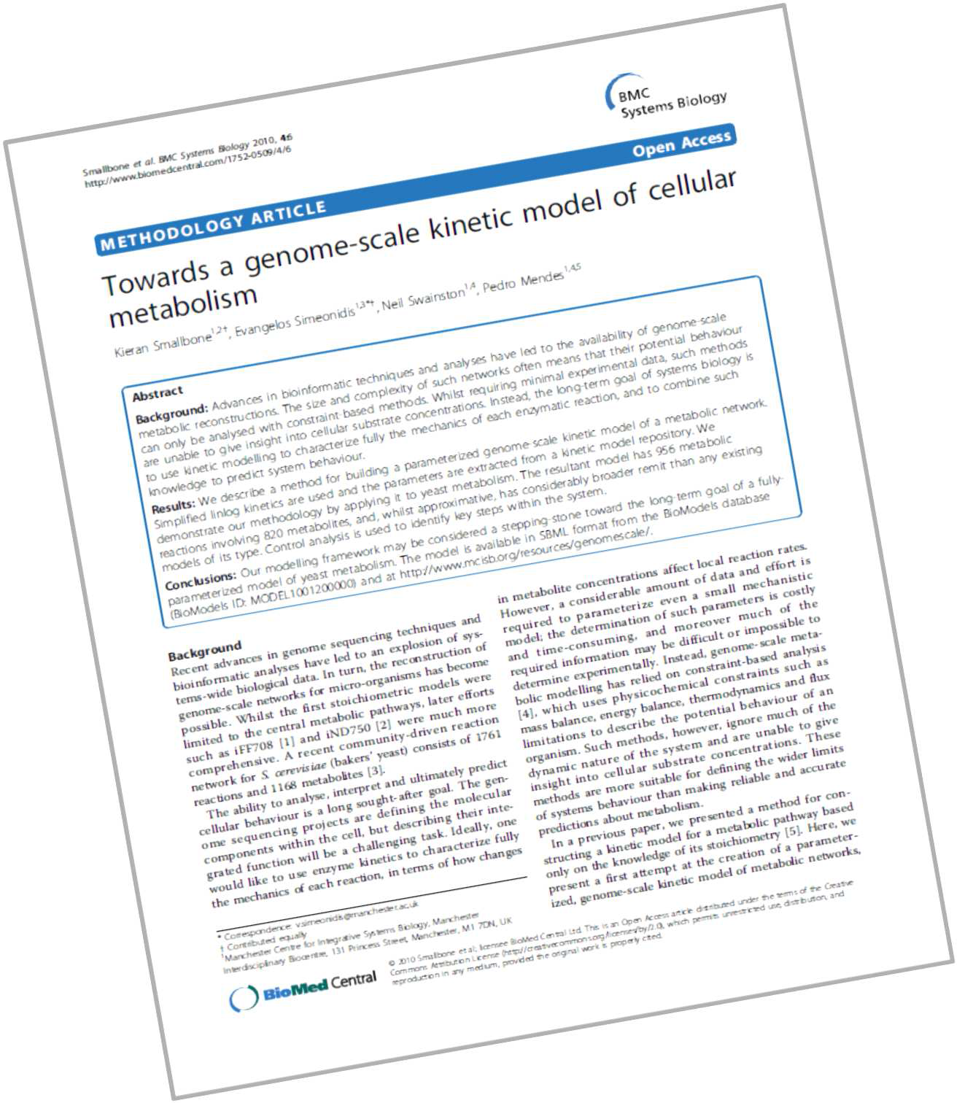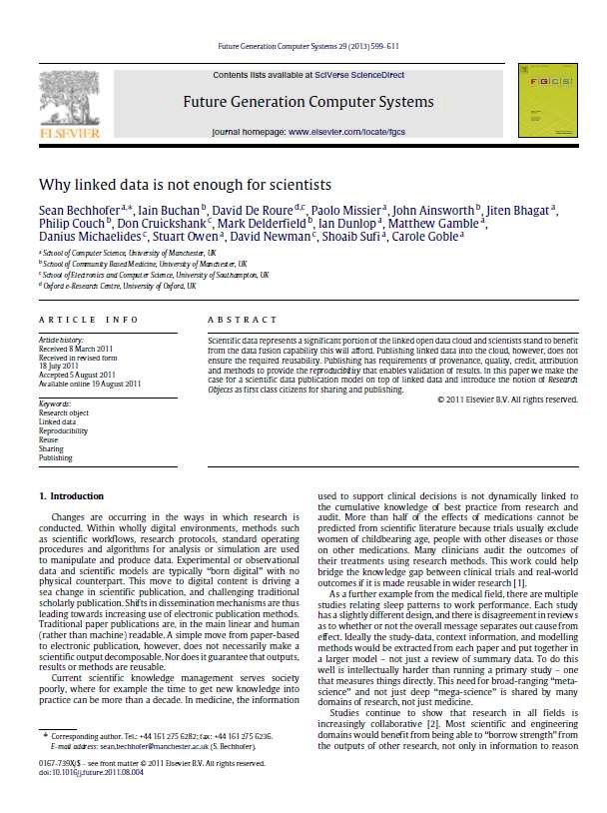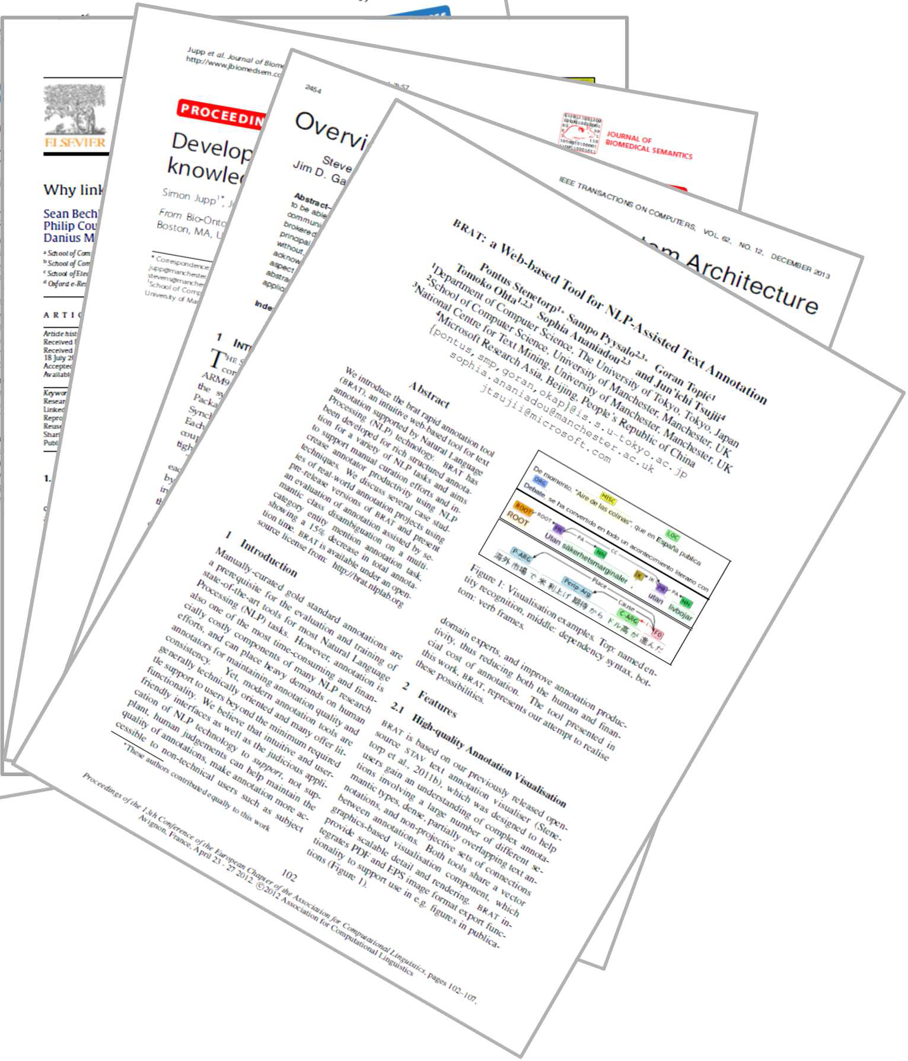Authors in Computer Science have ranked highly in a wide range of the Google Engineering and Computer Science topic areas with papers that have attracted significant numbers of citations. These include the following:

Bioinformatics & Computational Biology subcategory
- Towards a genome-scale kinetic model of cellular metabolism K Smallbone, E Simeonidis, N Swainston, P Mendes
ranked 8th in BMC Systems Biology (85 citations)

- Yeast 5–an expanded reconstruction of the Saccharomyces cerevisiae metabolic network
BD Heavner, K Smallbone, B Barker, P Mendes, LP Walker ranked 13th in BMC Systems Biology (71 citations)

- Large-scale generation of computational models from biochemical pathway maps
F Büchel, N Rodriguez, N Swainston, C Wrzodek, T Czauderna, R Keller, ... P Mendes
ranked 20th in arXiv Molecular Networks (q-bio.MN) (36 citations)

Computer Hardware Design subcateogory
- Overview of the SpiNNaker System Architecture

SB Furber, DR Lester, L Plana, JD Garside, E Painkras, S Temple, ...
ranked 10th in IEEE Transactions on Computers (71 citations)

- FPGASort: a high performance sorting architecture exploiting run-time reconfiguration on fpgas for large problem sorting
D Koch, J Torresen
ranked 7th in Symposium on Field Programmable Gate Arrays (FPGA) (51 citations)

Medical Informatics
‘These rankings really demonstrate the high level of work that takes place in the School and the sheer breadth of research we cover.’
Prof. Robert Stevens, Director of Research
o Developing a kidney and urinary pathway knowledge base S Jupp, J Klein, J Schanstra, R Stevens
th

ranked 17
in Journal of Biomedical Semantics (29 citations)

Computing Systems
- Why linked data is not enough for scientists
S Bechhofer, I Buchan, D De Roure, P Missier, J Ainsworth, J Bhagat, ... ranked =12th in Future Generation Computer Systems (152 citations)

Artificial Intelligence
- Conditional likelihood maximisation: a unifying framework for information theoretic feature selection
G Brown, A Pocock, MJ Zhao, M Luján
ranked 29th in The Journal of Machine Learning Research (164 citations)

Computational Linguistics
- brat: a Web-based Tool for NLP-Assisted Text Annotation
P Stenetorp, S Pyysalo, Goran Topic, T Ohta, S Ananiadou, Jun'ichi Tsujii
ranked 1st in Conference of the European Chapter of the Association for Computational Linguistics (129 citations)

- Incremental Joint POS Tagging and Dependency Parsing in Chinese J Hatori, T Matsuzaki, Y Miyao, Jun'ichi Tsujii
ranked 4th in International Joint Conference on Natural Language Processing (36 citations)

5
For past issues of the School of Computer Science Research Newsletter see www.cs.manchester.ac.uk/our- research/news/

Recent Promotions
Dr Gavin Brown obtained his PhD in 2004 from the University of Birmingham - the thesis won the British Computer Society Distinguished Dissertation Award. Immediately following this he was appointed to a Career Development Fellowship at Manchester, promoted to Lecturer in 2010, Senior Lecturer in 2012, and Reader in 2015. He has led several EPSRC and industry research projects - his research is around statistical Machine Learning, with particular focus on information theoretic and ensemble learning methods. In 2013, his PhD student Adam Pocock (co-supervised with Dr Mikel Lujan)

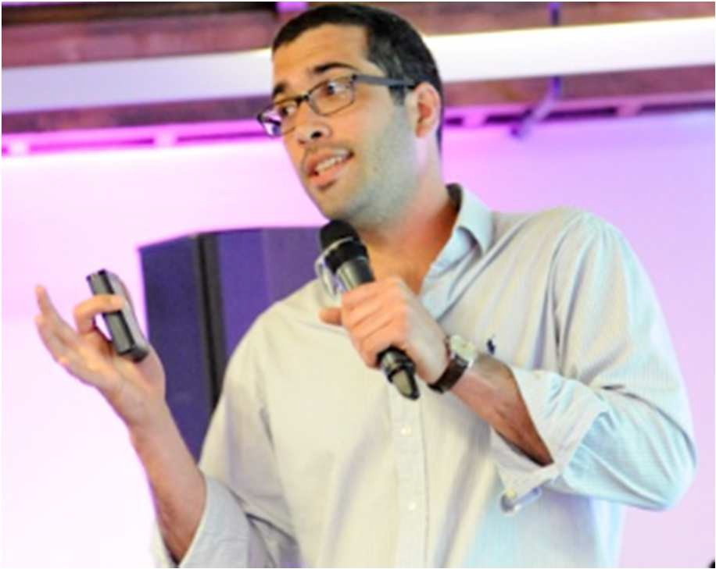
Machine Learning Research. www.cs.man.ac.uk/~gbrown

won the BCS Distinguished Dissertation Award again, making Brown/Pocock the only supervisor/student winners to win this national award. The main paper from this work is among the top 1% of highly cited papers in the Journal of

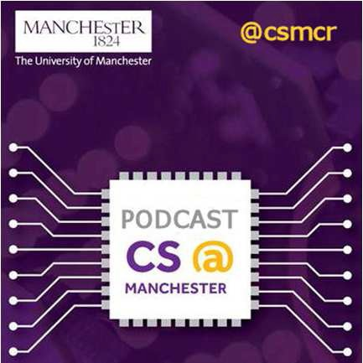
Gavin is a keen public communicator, most recently speaking at the Pint of Science Festival in May. The talk, titled Why the robots are not coming to kill us, explains and dispels public misconceptions of Artificial Intelligence.
Now available as the CS@Manchester podcast:
Subscribe on itunes: https://itunes.apple.com/gb/podcast/cs-manchester-podcast/id992446644 Or stream from our soundcloud page: https://soundcloud.com/cs-manchester-podcast

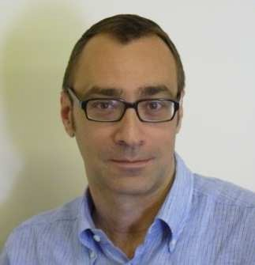Dr Goran Nenadic is a Reader in the School of Computer Science, with research interests in text analytics and semi-automated curation of knowledge from unstructured textual data. Current research projects mainly focus on large-scale extraction of biomedical information and clinical/epidemiological findings, by combing rule-based and data-driven approaches. His team is affiliated with the Manchester Institute of Biotechnology (MIB) and The Farr Institute’s Health eResearch Centre (HeRC), where he leads healthcare text mining efforts in collaboration with a number of local hospitals and charities. Goran has also worked with industrial partners to investigate sentiment analysis in social media (with QinetiQ), characterisation
of intent and behaviour using multi-media mining (QinetiQ), dynamic clinical documentation management (Siemens), contextualisation of molecular interactions from the literature (Pfizer), information extraction from clinical trial reports (AstraZeneca) and ontology-driven information and knowledge management (Unilever). He is the Editor-in-Chief of Journal of Biomedical Semantics. http://gnode1.mib.man.ac.uk.

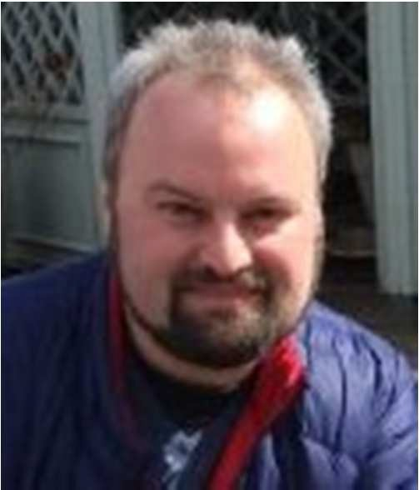Dr Dmitry Tsarkov is a Research Fellow in the Formal Methods Group within the School. He works on the EPSRC funded project REVES: REasoning in VErification and Security, specifically to further enrich iProver with a new functionality that allows it to solve verification problems formulated in a high-level language. Previously he worked in the Information Management Group on different areas of the Description Logic applications. Dmitry is the primary developer of highly successful Description Logic reasoners FaCT++ and Chainsaw that won several prizes on the ORE international reasoner competition.

Grants and awards

The School of Computer Science has been awarded over £16 million external funding for research over the last two years. Much of the research involves working in collaboration with others across the University and all over the world.
Here are just some examples of recent research funding awarded in the School.

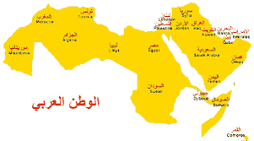Using half a trillion tweets to analyse sentiments in the Arab World
Prof. Allan Ramsay (Led by Qatar University) Funding body: Qatar National Research Fund Award amount: $195k

Digital social networks continue to grow with remarkable rates. Twitter is the fastest growing social network; with users in the Arab world tripling between March 2012 and March 2013 to 3.7 million.

The 500 million tweets that are generated daily represents rich data that can be analysed to measure public sentiments in areas like marketing, economics and politics. The algorithms and dictionaries that are used to identify positive, negative or neutral chatter have not yet been defined for the Arab world. In this two-year project we want to create Arabic dictionaries that capture words with positive and negative sentiment so that we can measure the sentiment of all Arabic tweets on any topic. These must cope with meanings in different dialects and usage comparisons in English and Arabic. www.cs.manchester.ac.uk/about- us/staff/profile/?ea=allan.ramsay

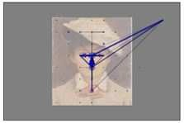Data-driven Eye Movement Analysis of Artwork

An ‘art-meets-science’ project in collaboration with Manchester Art Gallery.

Dr Caroline Jay
Funding body: EPSRC IAA Outreach Fund Award amount: £22k

This four-month project investigates the extent to which a new technique for computationally processing eye tracking data can be used to inform the display of artwork, add value to online digital collections, and enhance public understanding of both art and science. The project focuses on the application of Attention Approximation (AA), a novel method for visualising and
statistically interpreting how people view visual images, which is particularly well suited to use with naturalistic stimuli such as paintings.
It will investigate the potential for AA to inform the placement of painting labels (to enhance the display of artwork), and enable the creation of detailed visualisations and videos of gaze data for the gallery website, to be stored
alongside their digital collection of artwork. The project will entail a number of eye tracking demonstration events to be held at Manchester Art Gallery, and will culminate in a dedicated ‘Thursday lates’ public engagement event, showcasing project outputs. www.manchester.ac.uk/research/caroli ne.jay/

Transferring Semantic Expertise to Industry

Successful EPSRC IAA Relationship Incubator and Concept and Feasibility awards with Snap-on Business Solutions (SBS) have led to a KTP project with Telematicus.
Sean Bechhofer and Prof. Robert Stevens Funding body: Knowledge Transfer Partnership Award amount: £171k

Information management is a widely acknowledged challenge in the automotive, agricultural and construction sectors, exasperated by the complex and diverse range of products within the domain.
For example, in the production and management of vehicle service manuals, there are shared concepts (parts, or functional assembly of parts) that are covered in different information 'silos'. These shared concepts are not explicitly represented or exposed, leading to a lack of integration between information silos and inflexible hierarchical structures.

BigDataFinance
Prof. John Keane and Dr Xiaojun Zeng

Funding body: EC H2020 Award amount: €520k
The project will employ a Knowledge Transfer Associate to work with Telematicus, who in turn supply SBS with software. Research expertise in semantic technologies from Manchester, will be transferred to develop an ontology authoring tool to exploit emerging semantic web technologies in the development of information management systems. The tool will support search and navigation through parts catalogues and service information. www.cs.man.ac.uk/~seanb/

To exploit the potential of big data, banks and other financial institutions must be able to manage, process and use massive heterogeneous data sets in a fast and robust manner. Despite this, data analytic techniques are relatively little used in financial research and there is room to bridge finance and data science in general. Compared to the USA, Europe is still at an early stage of adopting Big Data technologies and services; immediate action is required to seize opportunities to exploit the huge potential of Big Data within the European financial world.
The EU-funded BigDataFinance project will investigate sophisticated data-driven risk management and research at the crossroads of Big Data and Finance. By considering the distributed nature of financial data storage and the velocity of financial markets, the project will develop distributed and real-time analytic methods to identify decentralized and dynamic models for financial market analysis, prediction and risk management, an important topic because capability for data analytics is increasingly critical for competitiveness. www.manchester.ac.uk/research/john.keane/

School of Computer Science

How can your business’ research benefit from working with us?

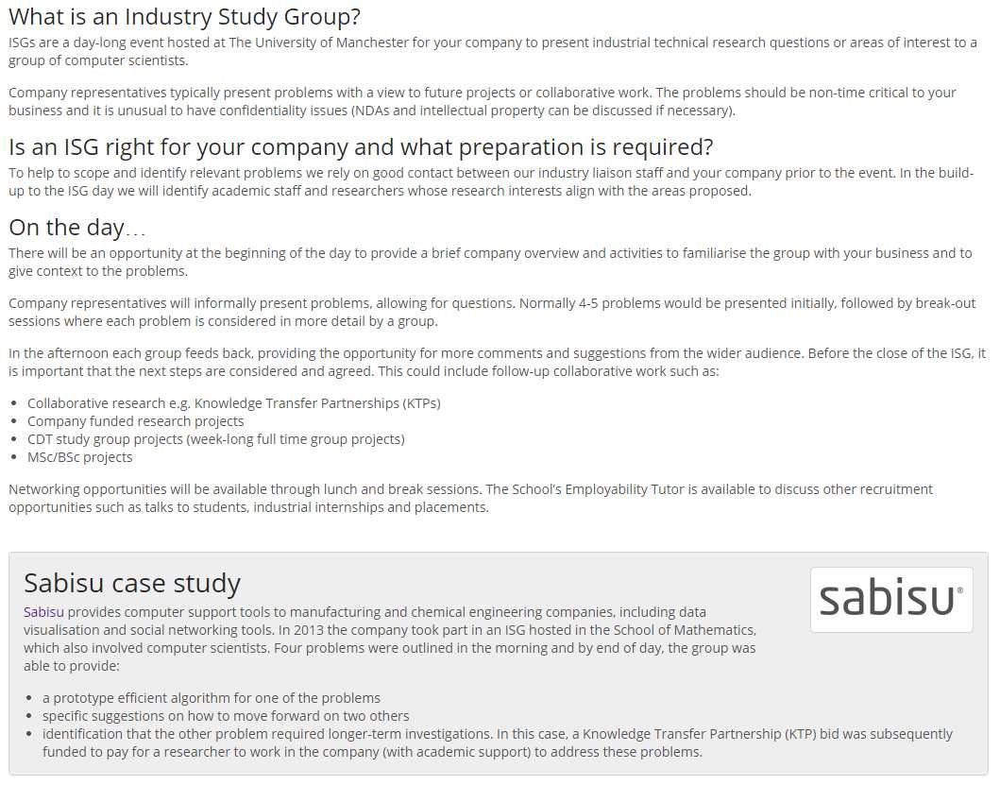

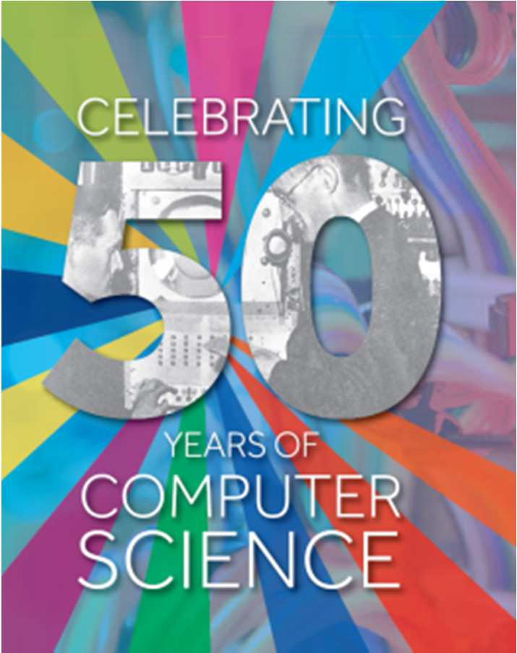8
Professor John Keane (Director of Externals) john.keane@manchester.ac.uk
Dr Jon Shapiro (Director of the Research School) jonathan.l.shapiro@manchester.ac.uk
Dr Sarah Chatwin (Research Support Manager) sarah.chatwin@manchester.ac.uk
Dr Duncan Hull (Employability Tutor) duncan.hull@manchester.ac.uk
Contact us
Industrial Liaison staff are available in the School to talk through any queries that you may have and to advise on whether an ISG is right for your company:

