Contact us

School of Computer Science
The University of Manchester
Kilburn Building
Manchester
M13 9PL
UK

Email: researchsupportcsm@manchester.ac.uk
Web: www.cs.manchester.ac.uk
The School of Computer Science - Kilburn Building
About us
At The University of Manchester, we have one of the longest established schools of computer science in the UK and one of the largest. We are constantly building on our strong research history with research groups operating across the spectrum of computer science, from fundamental theory and innovative technology, through novel hardware and software systems design, to leading-edge applications.
The School is consistently ranked highly; top 5% in the UK (REF2014, GPA); assessed as the best environment in the UK for computer science and informatics research (REF2014); and the expertise and achievements of our staff are well-recognised internationally.
In this issue

p.2 Head of School Editorial and Research News
p.5 Feature – Healtex
p.6 Recent Appointments and Promotions
p.7 Spotlight – School Research Symposium 2016
p.8 Grants and Awards
School of Computer Science
Research Newsletter
Issue 8 – Winter 2016/17
Editorial by the Head of School

We’re very pleased to welcome four new members of academic staff to the School of Computer Science. They bring with them a plethora of expertise across the discipline, from information management and text mining, to formal methods. We’re looking forward to working with them to further strengthen the school’s research areas.
In this edition of our Research Newsletter look out for some of the many examples of the successes and valuable work undertaken by our early career researchers, from PhD students to academic staff.

I’d also like to take this opportunity to wish you a happy new year and thank all of our research staff and support staff for their hard work in 2016.

Professor Robert Stevens

News
Success at World Championship for Automated Theorem Proving (CASC 2016)
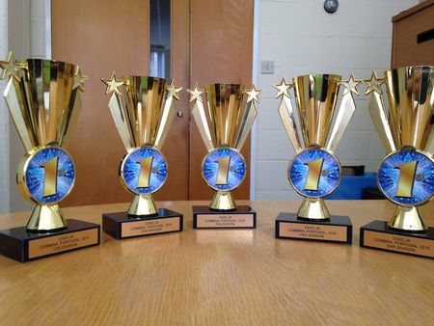
The teams behind Vampire and iProver have won major divisions in the annual World Championship for Theorem Proving (CASC) which was held at the International Joint Conference on Automated Reasoning (IJCAR), Coimbra. The Vampire team consists of Dr Giles Reger, Dr Martin Suda, and Prof. Andrei Voronkov and the iProver team consists of Dr Konstantin Korovin.
Manchester led the scoreboard in all 5 of the 8 divisions entered by Vampire and iProver. Vampire came first in 4 divisions and iProver came first in the effectively propositional (Bernays–Schönfinkel) class, a title historically held by iProver but taken by Vampire last year. For a second year Vampire won the arithmetic division, outperforming one of the leading SMT solvers.
Additionally, for the first year Vampire entered SMT-COMP (the World Championship for SMT solvers) and won 5 out 13 divisions entered. The competition contained very hard problems including those ranging over the theories of arrays and non-linear arithmetic. This can have a significant impact on the area as Vampire is not an SMT solver and uses techniques which are fundamentally different from those used by SMT solvers (i.e. instance-based methods).
These successes build on Manchester’s long history of world-leading theorem proving. Vampire has now won the main division (FOF) in CASC for 17 years in a row and in the history of the competition Vampire has won 38 trophies and iProver (starting 9 years later) has won 10.
Manchester Computer Scientists receive international award for research paper
A paper co-authored by Malte Vesper and Dr Dirk Koch and submitted to Proceedings of the 26th International Conference on Field-Programmable Logic and Applications, received the "FPL Community Award at the event held in Lausanne, Switzerland in July.
The award is for authors who have made a significant contribution by providing some material or knowledge in an open format that benefits the rest of the community.

The paper presents ‘JetStream’ an open-source modular PCIe 3 library, which supports not only fast FPGA-to-Host communication, but also allows direct FPGA-to-FPGA communication which fully bypasses the memory subsystem. This direct mode saves memory bandwidth for multicast modes and permits to connect multiple FPGAs in various software defined topologies.
The paper can be viewed through: http://wrap.warwick.ac.uk/81284/7/WRAP_fpl2016-vesper.pdf
Prof. Ananiadou international keynotes

In September Professor Sophia Ananiadou, Director of NaCTeM, was the keynote speaker at the 32nd International Conference on the Spanish Society for Natural Language Processing. The conference was held in the city of Salamanca between 13th and 16th of September as part of CEDI 2016.
Prof. Ananiadou also gave the keynote talk entitled "Text Mining - bridging the gap between knowledge and text" at the Data Analytics and Management in Data Intensive Domains (DAMDID).
This year the DAMDID conference was held in Ershovo, Moscow, Russia, from 11th - 14th October. It is a multidisciplinary forum of researchers and practitioners from various domains of science and research promoting cooperation and exchange of ideas in the area of data analysis and management in data intensive domains. The conference covers approaches to data analysis and management being developed in various areas, including different branches of informatics, social sciences, industry, new technologies, finance and business.
www.nactem.ac.uk/staff/sophia.ananiadou/

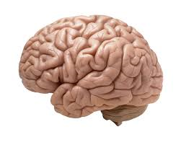
Professor Steve Furber on 'Artificial Intelligence vs. The Human Brain'
Prof. Furber has a blog post featured on the Huffington Post, in which he discusses whether artificial intelligence will ever supersede the human brain and the huge potential benefits that progress in this field could offer humanity.
www.manchester.ac.uk/research/steve.furber/

‘Junior Nobel Prize’ Commendation
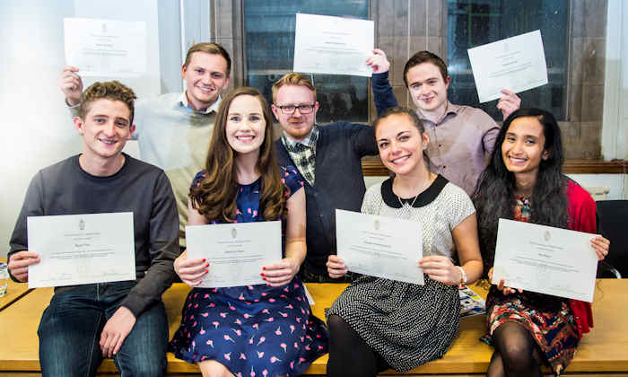
Veneta Haramplieva (pictured third from the left) received a special award from the University last week in recognition of her final year project being given a "Highly Commended" rating in the international Undergraduate Awards, aka the “Junior Nobel Prizes”, placing her project (supervised by Dr Gavin Brown) in the top 10% of undergraduates internationally, across all subjects. The scheme covered 244 universities worldwide, with a total of 5,514 project entries. Veneta was selected as one of the 9 best Computer Science projects worldwide – an exceptional achievement! Veneta's final year project looked at the problem of "stability" in Machine Learning algorithms, where she worked alongside a PhD student and helped push the state of the art in the area. You can read her project report here.
Veneta studied Computer Science with Industrial Experience. She graduated in 2016 and now works as a Software Engineer at Amazon.

Software sustainability recognition
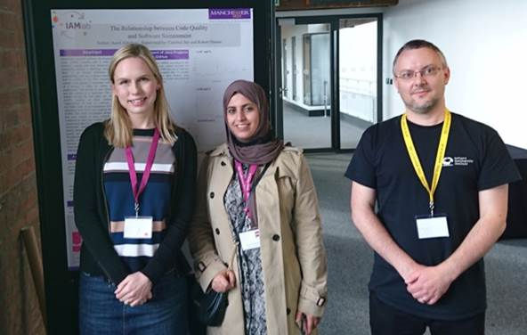
Congratulations to MSc student Aseel Aldabjan (pictured middle), whose work looking at software sustainability has been recognised by the international research software engineering community.

Aseel, supervised by Dr Caroline Jay and Robert Haines, presented the paper ‘How should we measure the relationship between code quality and software sustainability?’ at the 4th Workshop on Sustainable Software for Science: Practice and Experiences (WSSSPE4), before going on to win Best Poster, and £250 travel funding, at the inaugural Research Software Engineers' Conference, held at the Museum of Science and Industry.

Twitter competition success for PhD student

First year PhD student, Kurt Espinosa (supervised by Prof. Sophia Ananiadou and Dr Riza Batista-Navarro) , obtained very good results in a competition on social media analysis which was carried out within W-NUT 2016 workshop on Noisy User-generated Text co-located with the 26th International Conference on Computational Linguistics (COLING).
W-NUT focuses on natural language processing applied to noisy user-generated text such as that found in social media, web forums, online reviews, clinical records and language learner essays. Textual content from social media, in particular, is considered to be challenging due to its noisy nature.

This year, NaCTeM participated in one of the shared tasks, Named Entity Recognition(NER) in Twitter, and was ranked 3rd out of 10 teams. The competing teams were given around 3,800 tweets and were asked to detect and classify words or phrases into one of 10 categories (e.g., person, location, product, music artist, movie, sports team, tv show, company). Performance was evaluated against human-produced judgements. Kurt used a deep learning-based approach enhanced with weakly labelled data.

Light-weight text
Dr Simon Harper was quoted in the Daily Telegraph in October, on the subject of the readability of fonts on websites. The story also appeared in the Daily Mail.
Read the full article through: www.telegraph.co.uk/science/2016/10/23/internet-is-becoming-unreadable-because-of-a-trend-towards-light

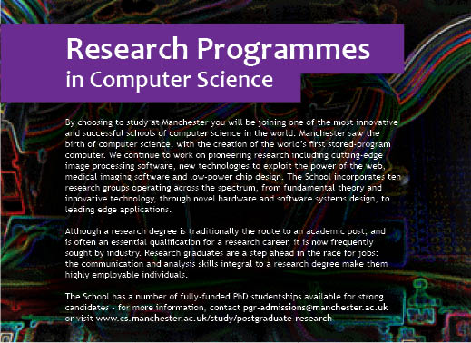
For past issues of the School of Computer Science Research Newsletter see www.cs.manchester.ac.uk/our-research/news/

Feature: Unlocking evidence contained in healthcare text

The UK healthcare text analytics research network (Healtex) aims to build a multi-disciplinary community of researchers interested in making sense of free text in healthcare. The network officially launched in Manchester on November 14th 2016 with 60 attendees across disciplines.
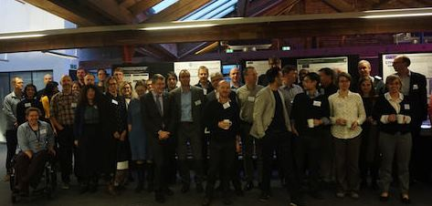
Healtex launch event in November 2016
There’s a huge amount of information within research and clinical practice in free-text format such as clinical notes, letters, social media posts and literature. New methods are needed to transform the written, free-text element of an electronic health record and healthcare social media into practical research data. These data can then be used by researchers to make health services more efficient and more responsive to patients’ needs.

The network is focused on:
- Identification of unmet needs and research challenges in healthcare text analytics,
- Exploration of the barriers to effectively utilising healthcare narrative text data,
- Designing the principles for sharing text data and text analytics methods between academia, NHS and industry

The unstructured free-text element of a patient’s medical records allows clinicians to add valuable context about their patients’ health, including symptoms, side-effects and disease progression. By translating this text into quantifiable datasets the information can be analysed by researchers to support and enhance existing sources of patient information like medication data and test results. Unlocking the free text data will provide a more accurate picture of the UK health and deliver powerful new insights into patient experiences. Health service providers will be able to quickly action these insights making services more efficient and treatments more effective.

Alongside the analysis of information from healthcare records, the research network will investigate how conversations on social media platforms can be harvested to further enhance the range and quality of research data. By capturing patient feedback and structuring this into relevant and practical information, patient voices will contribute to the improvement of health services and care pathways.
The network has been funded by EPSRC (UK Engineering and Physical Sciences Research Council) and is led by Dr Goran Nenadic. The network currently includes more than 100 researchers from over 20 UK universities, four partner organisations (the UK Renal Registry, Arthritis Research UK, HealthUnlocked, South London and Maudsley NHS Trust) and a number of National Healthcare Service trusts and private sector partners (including language technology and social media providers).
The launch event was followed by a workshop on “Unmet needs and challenges in using narrative data for clinical/epidemiological research”, the following day. Two panels, one consisting of clinicians and epidemiologists and the other featuring text miners and IT professionals, discussed research priorities that the network will aim to support in the next 3 years.
In addition to looking into free-text related to human health, the network also organised a workshop on veterinary text mining , aiming to support the One Health initiative to unite human and veterinary medicine.
More details at: http://healtex.org/

A variety of Healtex workshops and hackathons have already taken place and more events are planned for 2017, including:
- a Workshop on ‘Extracting evidence from clinical free text: opportunities and challenges’ that will be co-located with Informatics for Health 2017 24-26th April (Manchester) - academics, health professionals and industry partners will share the knowledge, insights and experience that are fueling the rapid advancement in informatics research for: health science; health care; and economic growth in and around digital health.
Recent appointments

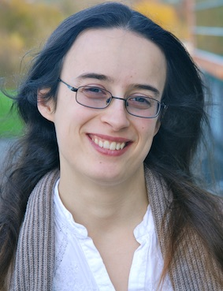
architectures for new and emerging application domains, and has a strong emphasis on human factors (e.g. privacy and trust, cognitive vulnerabilities). Application areas of interest include: personalisation of networked digital signage to improve wellbeing, social awareness, aesthetics of space etc.; collection, storage and presentation of large personal datasets in order to understand and augment human memory; and, the use of mobile and environmental sensing to provide feedback on emotional state and improve mental health. She is currently working with the NHS and BBC on privacy and consent management for smart environments. Dr Clinch was previously a postdoctoral researcher at Lancaster University and visiting scholar at the University of Cambridge. www.sclinch.com
Dr Sarah Clinch is a Lecturer within the Information Management group and the new “People to Data to Chips” theme. Her research focuses on the development and deployment of data-centric pervasive computing
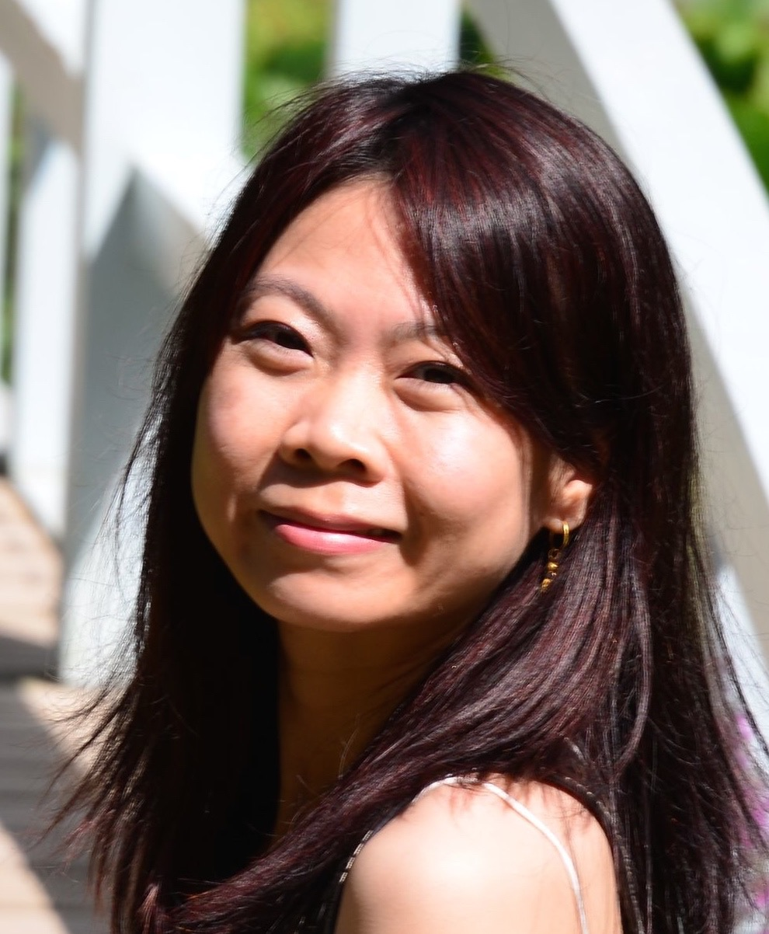
(1) simulate human intelligence and (2) analyse real-world complex data.
For (1), the aim is to construct effective machine learning models to automate tasks such as matching, recognition, prediction, ranking, inference, characterisation, language and vision understanding, etc. For (2), the aim is to develop algorithms to discover latent structure and extract information from large-scale, noisy and unstructured data, e.g., text, image, video, signal, network data, supporting development of text mining systems and other related research areas such as bioinformatics. www.cs.manchester.ac.uk/about-us/staff/profile/?ea=Tingting.Mu
Dr Tingting Mu (Lecturer) received her B.Eng. degree from School of the Gifted Young, University of Science and Technology of China in 2004, and Ph.D. degree from Department of Electrical Engineering and Electronics, University of Liverpool in 2008. Her research is focused on developing advanced mathematical modelling and large-scale optimisation techniques to:

authored more than 80 refereed papers (including best paper in 2008 and runner ups in 2012/2014) and has amassed a rich research experience extending to a range of topics from HPC to manycore architectures, passing by machine learning. His recent work on reliability of DRAMs against row hammer attacks has attracted seed funding and the memory controller is being prototyped as part of commercialisation efforts. Mikel is well known for his contributions in speculative parallelisation, transactional memory and dynamic binary modification and translation for ARM. http://apt.cs.manchester.ac.uk/people/mlujan/
Professor Mikel Luján holds a prestigious Royal Society University Research Fellowship in APT investigating low power many-core systems. He leads the UK-funded DOME project investigating fault tolerant many-core systems and is co-Investigator in the UK-funded PAMELA project (5-year grant). At the European level, he leads the Manchester team in the EU FET ExaNoDe, collaborates in the EU FET ExaNeSt and he led the Manchester team for the EU STREP FP7 project AXLE investigating acceleration of analytics for large European databases. Previously Mikel worked on runtime systems for HPC peta-scale systems for Sun Microsystems Research Laboratories (CA, USA) collaborating with the Hotspot JVM team. This work generated three US patents and was funded by DARPA/DOE. Since his first paper in OOPSLA 2000, Mikel has
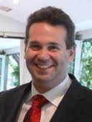
by Microsoft Research. In the area of dynamic program analysis, also known as runtime verification, he leads an international working group (via an EU-funded COST project) aiming to standardise languages and methods for dynamic program properties. He is also the lead developer of the MarQ runtime verification tool, which has won medals in the last three runtime verification competitions, which he now co-organises. This work includes on ongoing collaboration with NASA's Jet Propulsion Laboratory. www.cs.man.ac.uk/~regerg/

Dr Giles Reger joined the Formal Methods group as a Lecturer in Febuary 2016. He was previously a member of the group as a PhD student and research associate. His current research interests include automated reasoning and dynamic program analysis, both with a focus on software verification. Since 2014 he has been a main contributor to the world-leading Vampire theorem prover project, and has contributed to the recent successes at the CASC and SMT COMP competitions. Core to this success was the integration of VAMPIRE with the Z3 SMT solver developed

Recent promotions

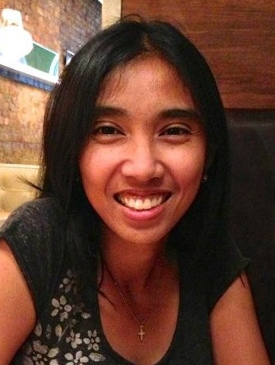
and metabolomics (as part of the BBSRC-funded EMPATHY project). A former assistant professor at the University of the Philippines Diliman, she obtained her PhD degree in Biomedical Text Mining from Manchester in 2014 under the supervision of Prof. Ananiadou, after which she took the role of postdoctoral researcher at NaCTeM. She participated in several editions of the highly visible international challenge in biomedical text mining, BioCreative, in which she obtained top-ranking results. Recently, she helped acquire funding to support the transformation of NaCTeM’s Argo text mining workbench into a federated machine reading system, which is aimed at promoting the integration of diverse NLP tools and services into text mining workflows with optimized performance. http://personalpages.manchester.ac.uk/staff/riza.batista/
Dr Riza Batista-Navarro is a newly appointed lecturer in the Text Mining group. Her research focus is on the analysis of large unstructured data, i.e., text, based on advanced natural language processing (NLP) methods. Through various projects at the National Centre for Text Mining (NaCTeM) that she has worked on, she has had opportunities to apply her approaches to information extraction on various domains: biodiversity (as part of the Mining Biodiversity project funded by Jisc), cancer biology (within the DARPA-funded Big Mechanism programme)
Dr Dirk Koch is a new lecturer in the APT group. His research interest includes reconfigurable computing, high-performance stream processing and tools for implementing run-time reconfigurable systems on Field Programmable Gate Arrays (FPGAs). His work is driven by the demand for providing more and more processing performance at much lower power consumption than conventional processors while simultaneously providing more flexibility and programmability in future reconfigurable computing systems. He is currently working on database acceleration using FPGAs where the goal is to build long processing pipelines that are able to perform hundreds of operations simultaneously at several gigabytes per second throughput. Before Dirk started his research on reconfigurable and parallel systems, he worked on power electronics and control systems during his Masters at the University of Paderborn, Germany. There he also worked on neural networks for classification and function approximation on coarse-grained CPU arrays. During his PhD at the University of Erlangen-Nuremberg, Germany, he developed novel techniques for self-adaptive distributed embedded control systems based on FPGAs. After this, he led a project at the University of Oslo, Norway which was targeting to make partial reconfiguration of FPGAs more accessible.

Spotlight: School Research Symposium 2016

Every year the School of Computer Science celebrates the work of its PhD students with a three-day Research Symposium, sponsored by IBM. The event was a great success, with 28 oral presentations from final year PhD students, an excellent keynote from Professor Gordon Blair at Lancaster University on ‘The Changing Face of Computer Science’, and over 50 poster presentations from second year PhD students.
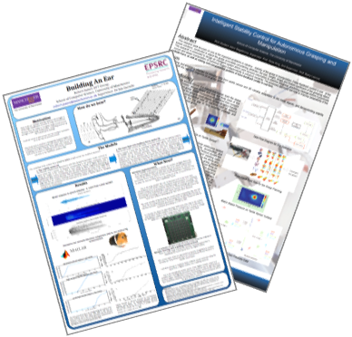

Dr Martyn Spink from IBM UK Limited kindly awarded prizes for best paper, best thesis, best paper runner-up and the best posters.

Best posters were voted for by a group of academics and visitors from a selection of very high quality presentations. Congratulations to the winners:

Robert James (supervised by Dr Jim Garside): Building an Ear Best poster

Ainur Begalinova (supervised by Prof. Ross King and Prof. Barry Lennox): Intelligent Stability Control for Autonomous Grasping and Manipulation Runner up

Other awards that were presented on the day:
- Best Thesis Prize was awarded to Patrick Koopman (supervised by Dr Renate Schmidt): ‘Practical Uniform Interpolation for Expressive Description Logics’
‘(because of the many interesting applications of this reasoning service) the thesis will generate a lot of interest and receive significant uptake.’

- Best Thesis Prize was also awarded to Konstantinos Sechidis (supervised by Dr Gavin Brown): ‘Hypothesis Testing and Feature Selection in Semi-Supervised Data’
‘The work represents a major step forward. ...the work makes an outstanding contribution to scientific knowledge with deep theoretical results well supported by empirical experiments.’

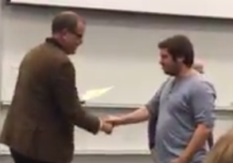

• Best Paper Award was awarded to Nikos Nikolaou, (pictured, supervised by Dr Gavin Brown) for ‘Cost Sensitive Boosting Algorithms: Do We really need them?’, Nara Edakunni Meelis Kull, Peter Flach, and Gavin Brown, Machine Learning Journal, 104(2), 359–384, 2016. Selected for the plenary at the EU Conference on Machine Learning 2016.

• Runner-up Best Paper Prize was awarded to James C. Knight (supervised by Prof. Steve Furber) for ‘Large-Scale Simulations of Plastic Neural Networks on Neuromorphic Hardware’, James Courtney Knight, Philip Joseph Tully, Bernhard A. Kaplan, Anders Lansner, Steve B. Furber, Frontiers in Neuroanatomy, 10(37), 2016.

• Runner-up Best Paper Prize was also awarded to Sukru Eraslan (supervised by Dr Simon Harper) for ‘Scanpath Trend Analysis on Web Pages: Clustering Eye Tracking Scanpaths.’ Yesilada, Yeliz; Harper, Simon. In: ACM Transactions on the Web, 2016.

For more information on the symposium please contact Dr Giles Reger http://studentnet.cs.manchester.ac.uk/pgr/symposium/

Grants and awards

The School of Computer Science has been awarded over £14 million external funding for research over the last two years. Much of the research involves working in collaboration with others across the University and all over the world.
Here are just some examples of recent research funding awarded in the School.

INSPEX: Integrated Smart Spatial Exploration System
Dr Richard Banach
Funding body: EU H2020
Award amount: €293k

GPS, IMUs, electronic compasses, smart phones and smart, mapped environments represent huge technological advances but they are of little use when your very next movement could cause you to walk into or trip over an unknown and unseen obstacle.
The project aims to develop a portable/wearable, multi-sensor, miniaturised, low power spatial exploration system. The INSPEX system will be used for real-time, 3D detection, location and warning of obstacles under all environmental conditions in indoor and outdoor environments with unknown static and mobile obstacles. For example, to aid mobility for the visually impaired, safer human navigation in reduced visibility conditions e.g. for fire fighters, and small robot/drone obstacle avoidance.
Current obstacle detection capabilities are only feasible on autonomous vehicles so further size and power reduction of the individual range sensors is key, whilst maintaining their functionality and performance.
Manchester’s expertise in modelling and verifying firmware and software blocks using one or more formal approaches will contribute to INSPEX’s software reliability and stability.
Manchester is one of 9 project partners across 6 countries in the €4M project, which is led by the French Alternative Energies and Atomic Energy Commission (CEA). www.cs.man.ac.uk/~banach/

AstraZeneca Data Science Fellowship for Dr Gavin Brown
Dr Gavin Brown
Funding body: Astra Zeneca
Award amount: £105k

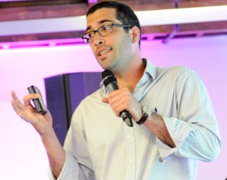
Gavin Brown (pictured) has recently received an award from AstaZeneca for an 18 month project which will apply machine learning techniques to analysis of clinical trials data.

The purpose is to explore new approaches to "subgroup discovery" in clinical trial data - which is an essential component of personalized medicine. For example, the research should be able to identify characteristics of patients that may respond well to drugs.
Kostas Sechidis is a fellow on the project and presented at the
NIPS 2016 Workshop on Machine Learning for Health (ML4HC), in Barcelona: ‘Ranking Biomarkers Through Mutual Information’ https://arxiv.org/abs/1612.01316
http://www.cs.man.ac.uk/~sechidik/

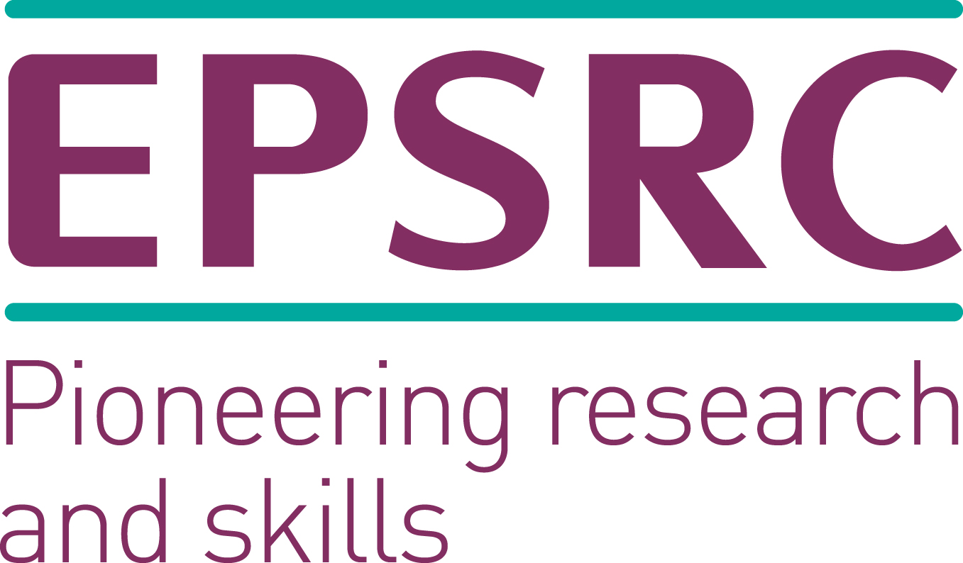
Doctoral Prize awarded to progress research past PhD-level
Congratulations to former PhD student Nikos Nikolaou, for his success in securing an EPSRC Doctoral Prize: a one year fellowship immediately following PhD that is designed to help researchers secure the next steps of an academic career.
Research is planned in Unifying Aspects of Machine Learning: From Boosting to Deep Learning (supervised by Dr Gavin Brown and Prof. Mikel Lujan). The long term goal is to establish the underlying connections between boosting and deep learning and to leverage them to improve their theoretical understanding, scalability, predictive ability and applicability to diverse scenarios (e.g. online learning, cost-sensitive learning, imbalanced class learning).
www.cs.man.ac.uk/~nikolaon/

