MIB - General Risk Assessment Form
Date:  07.05.2015 | Assessed by:  Jakub Ujma | Validated by:  Perdita Barran | Location:  LG046 |  | Review date:  06.05.2016
Task / premises:

INSTRUMENT DEVELOPMENT
Cooling instrumentation using solid CO₂/Liquid Nitrogen

Nitrogen (from the building’s supply) will pass through copper coil (Coil 1) immersed inside coolant medium (solid CO2/LN2). Cold nitrogen gas from the copper coil will be directed inside the vacuum chamber of the instrument (Coil 2). Output nitrogen will be directed outside the building using exhaust line.

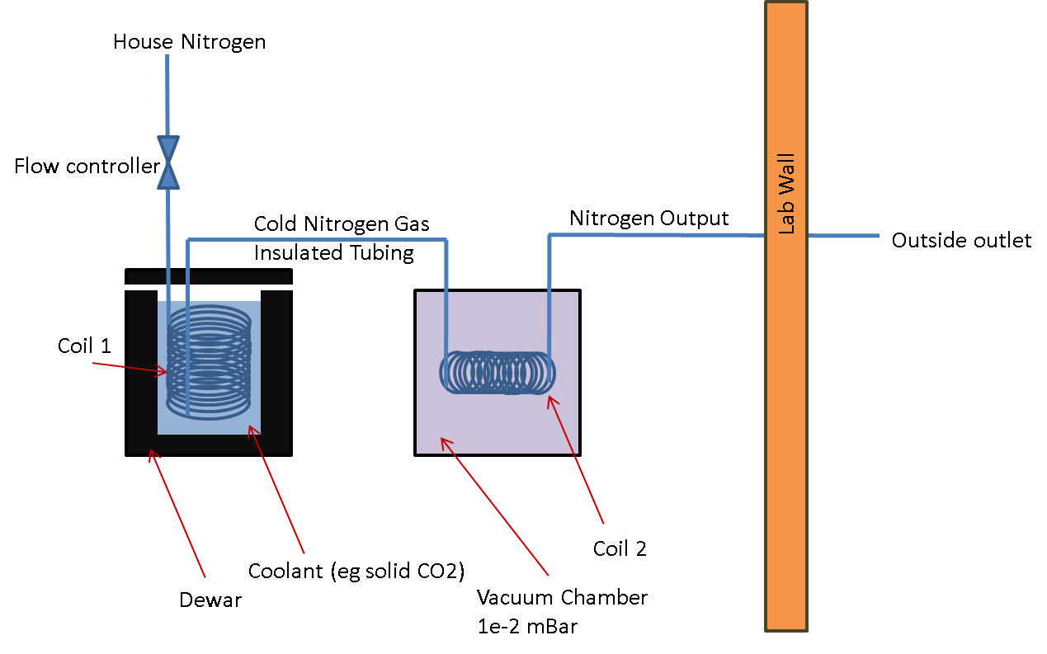

The nitrogen flow rate will not exceed 10 L/min and will be adjusted using a flow rate controller. The coolant medium (solid CO2 or liquid nitrogen) and the cooling coil will be placed inside a suitable container (eg. polystyrene box/small dewar) with a maximum volume of 3L. This will be stood inside secondary containment to minimise leakage. Liquid nitrogen will be placed inside the dedicated dewar of max volume of 50L. The flow rate will be controlled in order to minimise evaporation of coolant medium. The coolant container will be placed in close proximity (1.5m) to an oxygen depletion monitor and a carbon dioxide monitor. Cryogenic coolants will be handled with appropriate safety equipment (detailed below). The cooling operation will not exceed 5 hours and may be performed several times a week, typically several times a month. This work will not be conducted alone or out of hours.

Once the instrument development stage is complete, more stringent measures to control the process will be put in place and an SOP will be provided for users. Until then, only the person responsible for the project (Jakub Ujma) will be operating the setup.

The instrument has been placed in the restricted access area of the lab, and no other lab users but Jakub are permitted to be there.

Activity | Hazard | Who might be harmed and how | Existing measures to control risk | Risk rating | Result
Handling of solid CO₂ (dry ice) and liquid nitrogen | Asphyxiant  Contact with cryogen may cause severe cold burns. | Jakub Ujma  Lab users | All staff must be trained in the correct handling and transport of solid CO₂ and LN2(dry ice, liquid nitrogen)  All COSHH and risk assessment forms for procedures involving the use of solid CO₂/LN2are read and signed. All identified control measures will be followed.  All staff who handle/use dry ice / liquid nitrogen must attend a chemical safety course which details the risks associated with dry ice and liquid nitrogen, and what to do in case of a burn injury.  The following items of PPE must be worn when handling dry ice / liquid nitrogen: Howie-style laboratory coat, BS EN 511 compliant low-temperature gloves and BS EN166 compliant eye protection (chemical splash proof safety glasses; plus face visor when handling liquid nitrogen). A selection of safety glasses and goggles are available from MIB Stores; users are advised to visit Stores and select eye protection which fits well and is comfortable to use. Regular lab inspections monitor the wearing of PPE; users found not to be wearing PPE when the risk assessment states that it must be worn will be subject to the MIB compliance policy  Dry ice must be stored in suitably insulated containers to minimise the production of CO₂ gasLiquid nitrogen must be stored in suitable dewar to miminise the nitrogen gas boil-off.  Only use containers or fittings (pipes, tongs etc.) that have been designed specifically for use with cryogenic liquids as non-specialised equipment may crack or fail. In particular, do not use food type vacuum flasks as they can implode resulting in flying glass fragments.  Large volumes of carbon dioxide gas are evolved from small volumes of dry ice and this can easily increase CO₂ concentrations in air to dangerous levels in poorly ventilated areas leading to the danger of carbon dioxide poisoning (which is rapidly fatal at CO₂ concentrations >2.6%). Ensure that all work is performed in a well-ventilated area. For larger quantities of dry ice, an oxygen and CO₂ monitor/alarm must be used.  Large volumes of nitrogen gas are evolved from small volumes of liquid nitrogen (approximately 700 times) and this can easily replace normal air in poorly ventilated areas leading to the danger of asphyxiation. Maximum volume of nitrogen gas produced in case of spillage of entire liquid nitrogen in the lab must not deplete the oxygen level in the room to below 19%. Maximum volume of liquid nitrogen in this lab must not exceed 50L.  Oxygen condensed into leaking containers can explode on heating following resealing or blockage with ice.  Always use liquid nitrogen in a well ventilated area, especially when filling a warm container or transfer tube or inserting a warm object, as large volumes of nitrogen gas are evolved. (  All glass Dewars must be protected against the possibility of flying glass fragments, arising from failure by mechanical or temperature stress damage, by sealing all exposed glass either in an insulated metal can or by wrapping with adhesive tape.  Always fill warm Dewars slowly to reduce temperature shock effects and to minimise splashing. Do not overpressure storage Dewar when filling a globular Dewar. Use the minimum pressure required to maintain a flow of liquid.  Always make sure that containers of liquid nitrogen are suitably vented and unlikely to block due to ice formation.  Beware of the formation of liquid oxygen in cold traps that are open to air or the increase of liquid oxygen content in a flask of liquid nitrogen that has been cold for a long period. (Liquid oxygen has a blue water-like appearance). However, most liquid nitrogen containers are closed except for a small neck area and the nitrogen vapour issuing from the surface forms a barrier which keeps air away from the liquid thus preventing oxygen contamination.  Avoid skin contact with either liquid nitrogen or items cooled by liquid nitrogen as serious burns may occur.  In case of spill: Ventilate area well to avoid hazardous CO₂ concentrations from building up / depletion of oxygen levels. Use snorkel/LEV system to assist ventilation of area. CO₂ is a heavy gas & will remain in low spots without assisted ventilation.  First Aid:  In all cases of exposure, call an MIB first aider for assistance.  Inhalation: Remove to fresh air. Give artificial respiration if not breathing. If breathing is difficult, emergency oxygen should be given by an MIB first-aider and the emergency services summoned. The casualty should be seen by a doctor regardless of recovery rate.  Skin contact: Frozen tissues should be flooded/soaked with cold/tepid water. Don't use hot water. | Low | A
Using continuous flow of building nitrogen supply | Asphyxiation | Jakub Ujma  Lab users | There is a dedicated exhaust line, which vents to the outside.  A low flow rate is used.  There is an oxygen depletion alarm in close proximity to the experimental area.  The lab is a large room with good ventilation, and it is a restricted access area, so only authorised personnel can enter the area | Low | A
Handling potentially cold instrument parts | Burns | Jakub Ujma | The instrument design ensures that there is adequate thermal insulation (vacuum). Protective covers are also in place to prevent the user from coming in to contact with cold instrument parts.  In the case of skin contact: frozen tissues should be flooded/soaked with cold/tepid water. Don't use hot water. Call an MIB first aider for assistance. | Low | A
Electrical hazard | Electrocution | Jakub Ujma | Instrument is placed on custom made electrically insulating table, moreover, the insulating cover is in place. All electrical devices are PAT tested regularly. | Low | A
Chemical hazard | Exposure to chemicals / solvents | Jakub Ujma, lab users | Instrument has been designed to analyse minimal volumes of very dilute samples.  Analyte concentration typically <100 μM  Sample volume cannot exceed 30 μL (max volume of sample capillary)  Typical solvent media:  Aqueous buffers (typically 50 mM ammonium acetate)  Methanol  Acetonitrile  COSHH forms have been completed for all chemicals used, and the safety measures identified will be followed.  Samples will be prepared in the wet lab area, inside the fume hood. | Low | A
Manual handling of heavy parts | Strain Injury | Jakub Ujma | Instrument has been designed to be taken apart in sections, where the heaviest part weighs approx. 10kg. Heavy parts should not need to be taken off the instrument table, but they can be slid on the table surface without the need to lift. Individual must be physically capable of doing the task and understands how to perform these procedures safely. | Low | A
Working in awkward positions | Strain Injury | Jakub Ujma | Individual must be physically capable for doing the task and understands how to perform the procedures safely. | Low | A

Authorisation by PI

I confirm that I have considered and understand the experiment and the associated hazards. I am satisfied that all of the hazards have been identified and that the control measures to be followed will reduce the risks to acceptable levels.

Print name: Signed:

Date:

Declaration by researcher
I confirm that I have read this Risk Assessment and that I understand the hazards and risks involved and will follow all of the safety procedures stated. Where PPE has been identified as a control measure, I will ensure that it is worn.

Declaration by PI
I confirm that the researcher who has signed below is competent to undertake the work. My counter-signature indicates that I am happy for the work to proceed.

Name (please print) | signed | PI countersignature | date

